
JC2 PRELIMINARY EXAMINATION
TAMPINES MERIDIAN JUNIOR COLLEGE

_________________________________________________________________________________
H1 GEOGRAPHY 8834/01

Paper 1 1 September 2026 3 hours
INSERT

_________________________________________________________________________________

READ THESE INSTRUCTIONS FIRST

This Insert contains all the Resources referred to in the questions.

_________________________________________________________________________________

This document consists of 8 printed pages
Resource 1A for Question 1

The locations of the four survey areas in Singapore

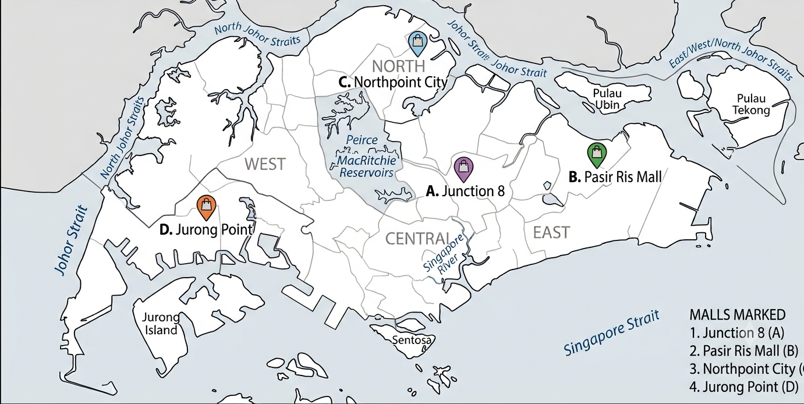

Resource 1B for Question 1

Food Outlet in Junction 8
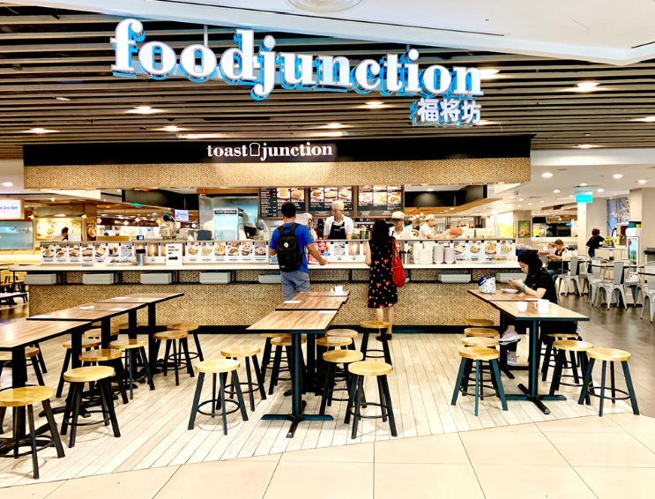

Resource 2 for Question 1
Questionnaire used by students

Questionnaire
Please circle the option that applies to you

- Age: 1 – 20 21 - 40 41-60 Above 60
- Gender: Male Female
- Do you recycle beverage containers? Yes No
- How do you recycle beverage containers? Reverse Vending Machines Others
- Please indicate how satisfied you are with the Reverse Vending Machines on a scale of 1 to 5 where 1 is Very Satisfied and 5 is Very Dissatisfied
Need  Ease of use  Availability of machine  Serviceability of machine  Amount of money refunded ($0.10/container) | Very Satisfied  1  1  1  1 | 2  2  2  2 | 3  3  3  3 | 4  4  4  4 | Very Dissatisfied  5  5  5  5
What do you like best about the Reverse Vending Machines? Please explain your answer.

Thank you for your time.

Resource 3 for Question 1

Selected results of the survey

 | Very Satisfied |  |  |  | Very Dissatisfied
Ease of use | 7 | 14 | 18 | 20 | 1
Availability of machine | 15 | 15 | 18 | 10 | 2
Serviceability of machine | 35 | 15 | 5 | 3 | 2
Amount of money refunded ($0.10/container) | 7 | 7 | 6 | 20 | 20
Total surveyed: Male = 30; Female = 30

Resource 4 for Question 2

Top 10 Most Liveable Cities (EIU’s Global Liveability Index 2026)

Rank | City | Country
1 | Copenhagen | 🇩🇰 Denmark
2 | Vienna | 🇦🇹 Austria
3 | Melbourne | 🇦🇺 Australia
4 | Sydney | 🇦🇺 Australia
5 | Zurich | 🇨🇭 Switzerland
6 | Geneva | 🇨🇭 Switzerland
7 | Osaka | 🇯🇵 Japan
8 | Adelaide | 🇦🇺 Australia
9 | Vancouver | 🇨🇦 Canada
10 | Tokyo | 🇯🇵 Japan

Resource 5 for Question 2

Map of Top 10 and bottom 10 cities (Mercer Quality of Living City Ranking, 2024)

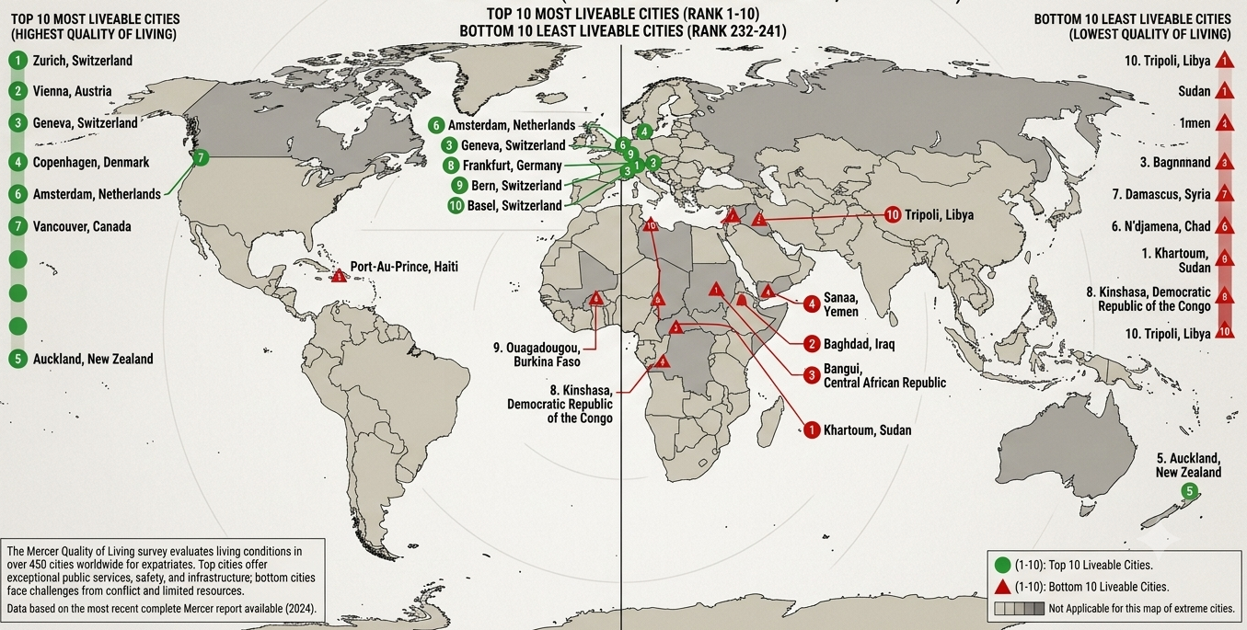

Resource 6 for Question 2

China’s Urban Sustainability indicators compared to developed world standards, 2022

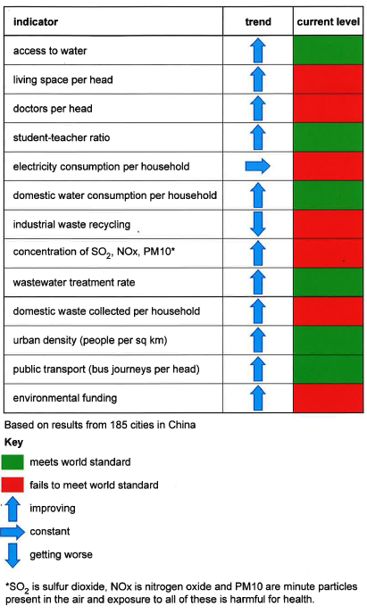

Resource 7 for Question 3
Annual Average Temperature of Singapore, 1990 - 2026

Resource 8 for Question 3
Circles of sustainability for Beijing and Singapore
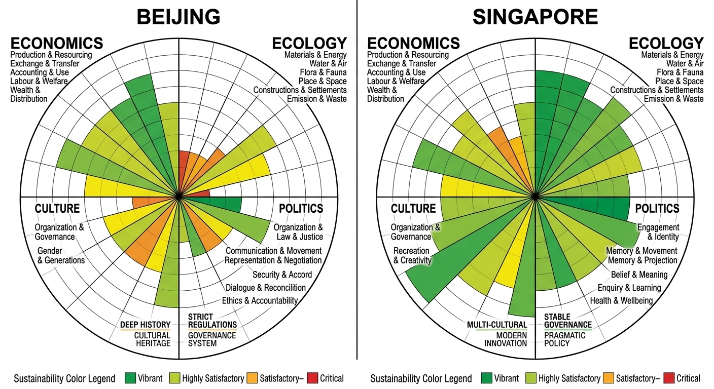
Resource 9 for Question 3
Rooftop garden at Kampong Admiralty vertical retirement village
